|  |  |
| --- | --- |
|  | Introduction to information system  Name : Mahmoud Mohammed Mahmoud Desoky  ID : 20182987 Group : A1.2  Coca Cola Case Study  Supervisor : Maha Farghaly |

# **Coca Cola**

Coca-Cola is a cola (a type of carbonated soft drink) sold in stores, restaurants, and vending machines. It is produced by The Coca-Cola Company (United States).   
  
The Coca-Cola Company offers nearly 400 brands in over 200 countries or territories, which shows its reorganization.  
  
The Coca-Cola Company only produces concentrate syrup which is then sold to various bottlers throughout the world who hold a Coca-Cola franchise.  
  
**Main Competitors**   
  
Pepsi is Coca-Cola's main competitor, selling alternative and similarly priced beverages.  
  
Coca-Cola has focused on different advertising schemes compared to Pepsi, Coca-Cola focuses on friends, family, and happiness.  
  
On the other hand, Pepsi focuses on a cooler and more modern style of advertising showing more intense scenes where as Coca-Cola is more relaxed.  
  
**MARKETING STRATEGY**   
  
Coca-Cola has introduced a variety of new products to the Coke lines. These include multiple flavors, diet, and zero-sugar versions of Coke.  
  
The products have been similar in terms of source, they all have the original Coke taste, but their differences come in the flavor or sugar content usually.   
  
Coke has been endorsed by the likes of NASCAR and the London Olympics.   
  
Coke has its own social media accounts where it releases pictures and advertisements, as well as promotions such as free Coke, etc.  
  
  
  
**Employee Base**  
  
Higher Management  
- CEO (the owner of the company or the owner of the capital).

- Board of Directors (consisting of shareholders).

### Middle Management

- Operational management (sales, marketing, production, and public relations).

- Executive Management (Legal Department, Materials Management and Maintenance).

### Lower management

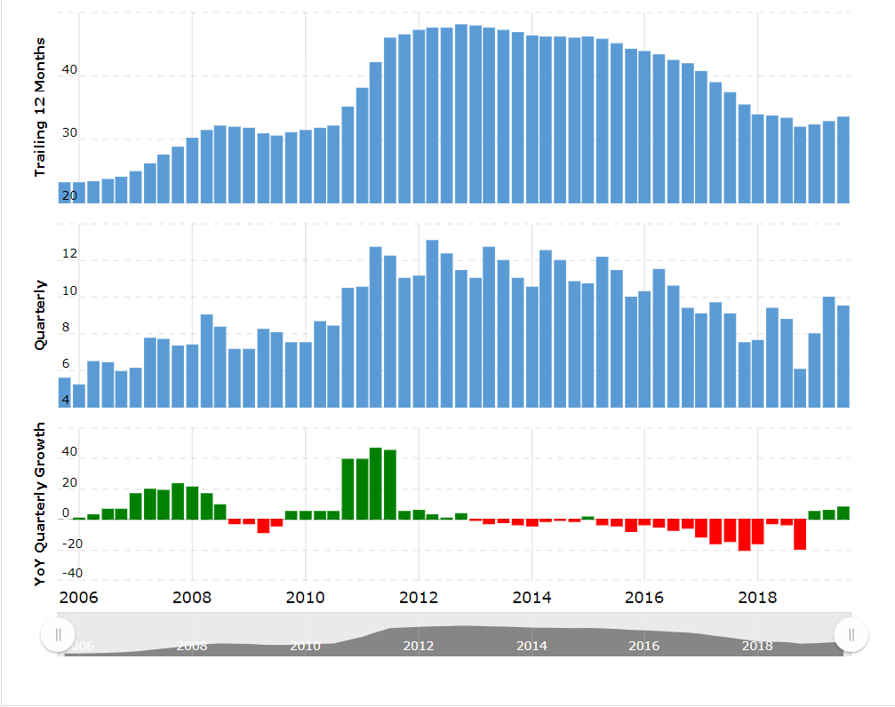  Officials of executive and operational teams, employees, technicians, and administrators.  
  
**Financial Statement**  
  
Coca-Cola's annual/quarterly revenue history and growth rate from 2006 to 2019. Revenue can be defined as the amount of money a company receives from its customers in exchange for the sales of goods or services. Revenue is the top line item on an income statement from which all costs and expenses are subtracted to arrive at net income.  
  
**Mission**  
- To refresh the world.  
- To inspire moments of optimism and happiness.  
- To create value and make a difference.   
  
**Vision**  
  
- People: Be a great place to work where people are inspired to be the best they can be.  
- Portfolio: Bring to the world a portfolio of quality beverage brands that anticipate and satisfy people's desires and needs.  
- Partners: Nurture a winning network of customers and suppliers, together we create mutual, enduring value.  
- Planet: Be a responsible citizen who makes a difference by helping build and support sustainable communities.  
- Profit: Maximize long-term return to shareowners while being mindful of our overall responsibilities.  
- Productivity: Be a highly effective, lean, and fast-moving

**Values**  
  
- Leadership: The courage to shape a better future.  
- Collaboration: Leverage collective genius.  
- Integrity: Be real.  
- Accountability: If it is to be, it's up to me.  
- Passion: Committed in heart and mind.  
- Diversity: As inclusive as our brands.  
- Quality: What we do, we do well.  
  
**Focus**  
  
- Focus on the needs of our consumers, customers, and franchise partners.  
- Get out into the market and listen, observe and learn.  
- Possess a worldview.  
- Focus on execution in the marketplace every day.  
- Be insatiably curious.  
  
  
  
  
**Success Criteria**  
  
1. Coca-Cola started with a unique product to test the market.  
2. The company logo is designed indefinitely.  
3. The drink was distributed in unique bottles.  
4. The company contracted with retailers to maintain its high standards.  
5. The prices of the company's products have been fixed to consumers for over 70 years.  
6. Coca-Cola has launched extensive advertising campaigns to publicize its brand.  
7. Coca-Cola adopted a concession approach.

**Coca Cola ERD**

